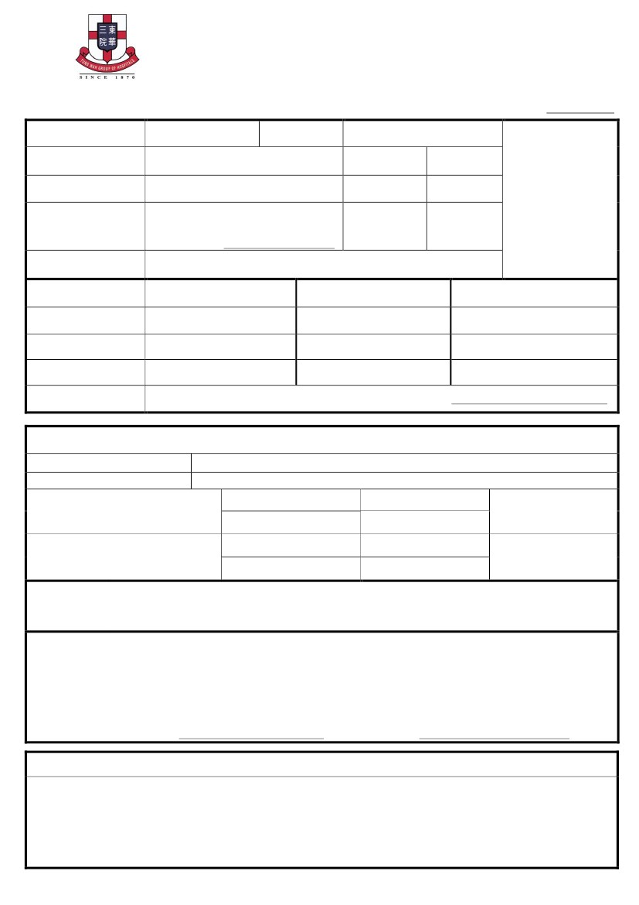
崇真會美善幼稚園
Tsung Tsin Mission Graceful Kindergarten
2018/19 學年入學申請表
Application Form for Admission in the 2018/19 School Year
中文姓名
Name in Chinese
申請編號
Application No.:
英文姓名
出生日期
Date of Birth
性別
Sex
Name in English
□ 男M
□ 女F
請貼上近照
Affix here
a recent photo
＃出生證明書號碼
＃Birth Certificate No.
出生地點
Place of Birth
家中常用語言
Spoken language at home
住址
Home Address
□廣東話 Cantonese □英語 English
□普通話 Mandarin
□其他 Others
住宅電話
Home Telephone
家長資料
Parent’s Particulars
父親
Father
母親
Mother
監護人資料
(請註明關係)
(
)
Guardian’s Particulars (Relationship)
中文姓名
Name in Chinese
職業
Occupation
聯絡電話
Telephone No
手
提
□母 Mother
手
提
手
提
）
Mobile No
Mobile No
Mobile No
照顧者
Caregiver:
□父 Father
□其他 Others 請註明 Please specify：（
＃If Identity Document(s) other than Birth Certificate is used, please specify.
＃如使用出生證明書以外身份證明文件 請註明。
□ 如未能按申請意願編配，本人願意接納校方的安排。
If assignment is not consistent with my choice, I am willing to accept the school’s arrangement.
申請學制 Preferred Session □ 上午 AM □ 下午 PM □ 全日 WD
申請班級 Applied Class
現於本校就讀的親友
*請遞交有關證明副本
□ 幼兒班 K1
姓
班
姓
名 Name
別 Class
名 Name
□ 低班 K2
□
高班 K3
關係 Relationship
Relatives studying at this kindergarten
*Please submit a copy of supporting document
曾於本校就讀的親友
*請遞交有關證明副本
關係 Relationship
Relatives graduated from this kindergarten
* Please submit a copy of supporting document
畢業年份 Year of Graduation
認識本校途徑：□郵寄單張 Leaflet □親友介紹 Introduced by relatives and friends □本校網站 School website □本校面書專頁 School Facebook
Learn about our □報章 Newspaper / Magazine: ________ □廣告 Advertisement: __________ □其他網站 Other website: ___________
school by: □其他 Other：____________

本人在申請表上所填寫的一切資料均屬真確，申請人所提供的資料只用於處理入學申請之用，並同意若申請人未獲取錄或自
動放棄學位，有關資料將於一年內全部銷毀。根據個人資料（私隱）條例規定，申請人有權要求查閱、更正及更新其個人資
料。如有查詢，請與本園聯絡。
I hereby certify that the information provided is true and accurate. I understand that all information provided to the school during the enrolment process will be treated
confidentially. Records will be permanently destroyed within one year if I give up the enrollment or are not shortlisted. In accordance with the Personal Data (Privacy)
Ordinance, applicants have the right to access, correct and update their own personal data. Please approach our school for any enquiries.

家長/監護人簽署
Signature of Parent/Guardian：
日期
Date：
以 下 由 校 方 填 寫 (FOR OFFICE USE ONLY)
□出示出生證明書正本或居港證明書正本及 □遞交副本
Provided applicant’s original Birth Certificate or valid Hong Kong resident visa and Submitted a copy
□遞交近照一張（不包括報名表上的相片），背面寫上該生姓名
Submitted one recent photo of the applicant(exclusive of the affixed photo)with name written at the back
□遞交回郵信封3個，並需貼上足夠郵資 □繳交＄40報名費(現金或支票)支票抬頭:崇真會美善幼稚園
Submitted three stamped self-addressed envelopes ＄40 application fee by cash or cheque pay to Tsung Tsin Mission Graceful Kindergarten
